**Likert Scale**

**The following choices may help you when you** [**design an attitude instrument**](http://www.gifted.uconn.edu/siegle/research/Instrument%20Reliability%20and%20Validity/instdeve.html)**. The bold face sets are the most popular.**

**AGREEMENT**

|  |  |  |  |
| --- | --- | --- | --- |
| * **Strongly Agree** * **Agree** * **Undecided** * **Disagree** * **Strongly Disagree** | * Agree Strongly * Agree Moderately * Agree Slightly * Disagree Slightly * Disagree Moderately * Disagree Strongly | * Agree * Disagree | * Agree * Undecided * Disagree |
| * Agree Very Strongly * Agree Strongly * Agree * Disagree * Disagree Strongly * Disagree Very Strongly | * Yes * No | * Completely Agree * Mostly Agree * Slightly Agree * Slightly Disagree * Mostly Disagree * Completely Disagree | * Disagree Strongly * Disagree * Tend to Disagree * Tend to Agree * Agree * Agree Strongly |

**FREQUENCY**

|  |  |  |  |
| --- | --- | --- | --- |
| * **Very Frequently** * **Frequently** * **Occasionally** * **Rarely** * **Very Rarely** * **Never** | * **Always** * **Very Frequently** * **Occasionally** * **Rarely** * **Very Rarely** * **Never** | * Always * Usually * About Half the Time * Seldom * Never | * Almost Always * To a Considerable Degree * Occasionally * Seldom |
| * A Great Deal * Much * Somewhat * Little * Never | * Often * Sometimes * Seldom * Never | * Always * Very Often * Sometimes * Rarely * Never |  |

**IMPORTANCE**

|  |  |  |
| --- | --- | --- |
| * **Very Important** * **Important** * **Moderately Important** * **Of Little Importance** * **Unimportant** | * Very Important * Moderately Important * Unimportant | * Very Important * Important * Neither Important or Unimportant * Unimportant * Very Unimportant |

**QUALITY**

|  |  |  |
| --- | --- | --- |
| * Very Good * Good * Barely Acceptable * Poor * Very Poor | * **Extremely Poor** * **Below Average** * **Average** * **Above Average** * **Excellent** | * Good * Fair * Poor |

**LIKELIHOOD**

|  |  |  |
| --- | --- | --- |
| * **Like Me** * **Unlike Me** | * To a Great Extent * Somewhat * Very Little * Not at All | * True * False |
| * Definitely * Very Probably * Probably * Possibly * Probably Not * Very Probably Not | * **Almost Always True** * **Usually True** * **Often True** * **Occasionally True** * **Sometimes But Infrequently True** * **Usually Not True** * **Almost Never True** | * True of Myself * Mostly True of Myself * About Halfway True of Myself * Slightly True Of Myself * Not at All True of Myself |

**Sample Front Page from an Instrument Using a Likert Scale...**

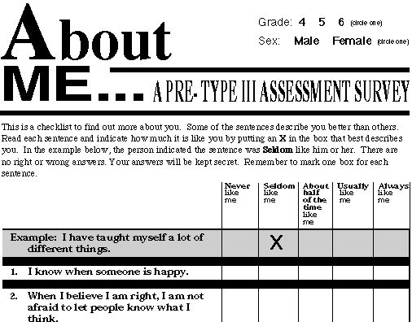  
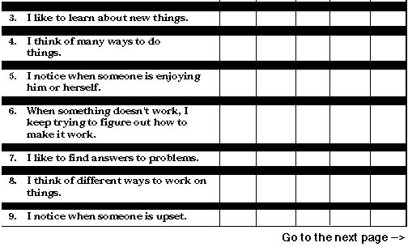

Del Siegle, Ph.D.  
Neag School of Education - University of Connecticut [del.siegle@uconn.edu](mailto:del.siegle@uconn.edu)  
[www.delsiegle.com](http://www.delsiegle.com)

11/24/2010